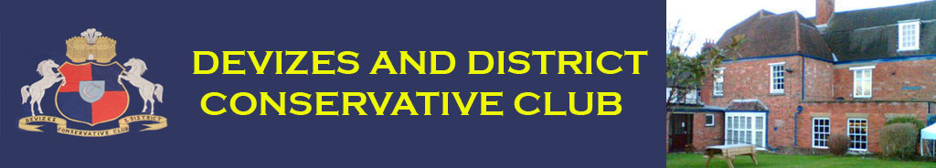CLUB NEWSLETTER SEPTEMBER 2018
“Wilsford House” 30 Long Street, Devizes, Wilts SN10 1NW Tel 01380 722005
www.devizesconsclub.co.uk
email: devizesconservativeclub@hotmail.com
Lounge Events
Saturday 13th October
Matt’s Pie & a Pint Reward Evening
Members: £3 Non Members: £6
Tickets available from the lounge bar
Saturday 29th September
9 pm Music in the Lounge
Free to Members & Guests

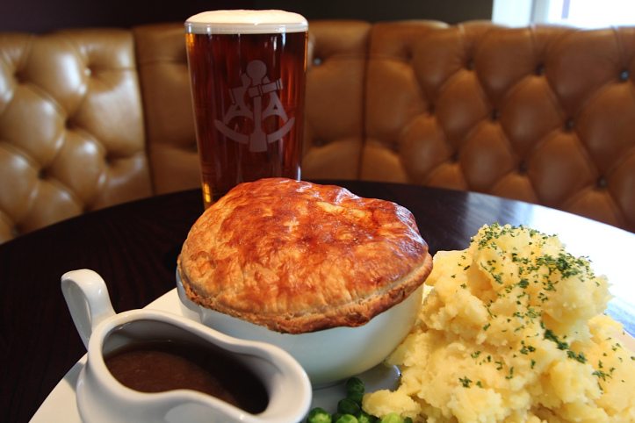

All pies are served with mash, peas and gravy as standard
Choose from the following selection when booking:-
~ Steak & Ale ~~ Creamy Chicken & Smoked Bacon ~
~ Blue Pumpkin, Stilton and Butternut Squash ~
Choose your drink at the bar on the night
A pint of beer, lager or cider, A small glass of wine or a soft drink

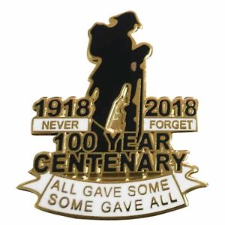

Saturday 10th November
WW1 Armistice Centenary Commemoration Club Event
Lounge Doors open 7.30 pm Ceremony Commences 8 pm
Tickets: £5 with all monies going to the Royal British Legion’s Poppy Appeal. A ticket entitles you to a meal, a drink, a quiz & music from the era.
Smart casual dress. Personal medals may be worn, also medals of family members particularly those associated with WW1 & WW2, these are to be worn on the right side of the chest.

Club Christmas Menu Starter
Winter parsnip, chestnut & stilton soup served with warm ciabatta
~
Smoked haddock & leek tartlet with a pickled beetroot & lambs leaf salad
~
Chicken liver & brandy pate with toasted rye bread & pickles
~
Classic prawn cocktail with a spicy Marie rose sauce
Main
Traditional turkey & stuffing
~
Silverside roast beef with Yorkshire pudding
~
Mixed nut & bean roast with veggie gravy
Above mains with roast potatoes & parsnips, buttered carrots, sprouts & red cabbage
~
Salmon fillet with a salsa Verde, a potato rosti & winter greens
Dessert
Xmas pudding with a whiskey cream
~
Warm cranberry & white chocolate brownie with vanilla ice cream
~
Sticky toffee pudding with toffee sauce & clotted cream
To finish
Filter coffee/freshly brewed tea/mince pie
Adult 3 course - £23.95 2 course - £17.95 Small plate 3 course - £18.95 2 course - £12.95
Bookings now being taken for Sunday 2nd December 12 - 3 pm, Thursday 13th & 20th December 12 - 2 pm. Please book at the bar. Orders must be placed 1 week in advance.
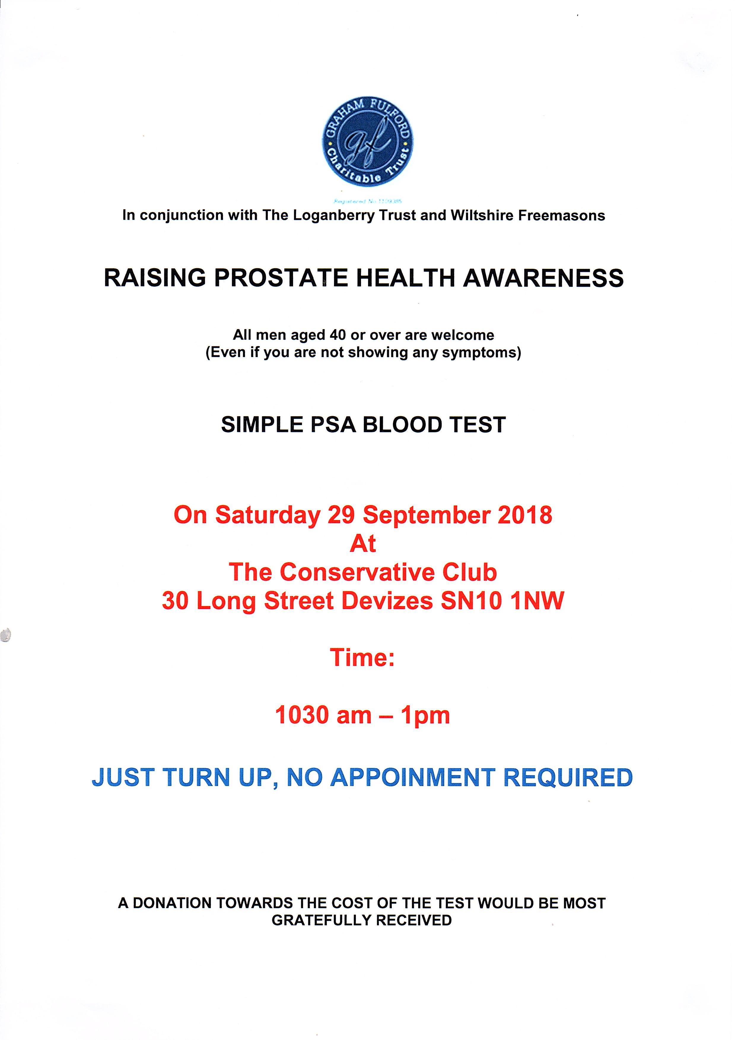
Charity Bingo Night

Sunday 18th November 2018
at Devizes Conservative Club
Doors open 7.30 pm 8 pm Start

Entry fee £1.00

£3 a book for 7 games & £1 each for flyers
Cash Prizes
All donated raffle prizes welcome with all proceeds going towards Help for Heroes plus 15% of all book proceeds.

Members Reward Evening - Port & Cheese Tasting
What a wonderful evening this was with 56 members attending this very successful event in the lounge.
Seven ports were on offer and six cheeses from various countries and I am sure that all that attended will agree there was more than plenty to go around. To keep members occupied throughout the evening Chris Jones put together a cheese “quiz” which definitely added enjoyment and a competitive spirit to the proceedings. There were 3 winners:- Fiona Babbings, June Potts and Sheila Aiston - each receiving a £10 club voucher.
Many thanks to Chris for sourcing the port and the cheese, to Andrew for co-hosting and to Blake and Stacey for setting up the event.

Charity Bingo Evening in aid of Devizes & District Link Service
£400 was raised on Friday 24th August at the Club for this local “Good Neighbour” scheme which provides transport, information and company to residents living in the Devizes District and surrounding villages. The event was hosted by Janine and Mandy Chowney Andrews and attended by Peter Evans, Chair of Devizes & District Link. Many thanks to all those who donated raffle prizes, including Barbara Wordley for the magnificent cake she baked, and all those who were more than generous when buying raffle tickets.

It’s that time of year again (already)
Christmas draw tickets are on sale from September 1st
20p a number or £40 for the whole sheet
Please ensure you get your entry countersigned by the bar staff or a committee member.
Bingo Dates
7 games for £3 a book, 2 x flyers for £1 per book.
New players are welcome.
A selection of rolls will be available.
Please check dates carefully as they are a mixture of Fridays and Sundays.

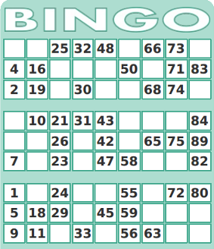Friday 7th September, Friday 21st September, Friday 5th October,
Friday 19th October, Sunday 4th November,
Sunday 18th November - Charity in aid of Help for Heroes,
Sunday 2nd December - *Revised date*
Friday 21st December - Christmas bingo & free buffet doors open 7 pm
After the Christmas break bingo will re-commence Sunday 13th January

Forthcoming Events

Saturday 8th September
Quiz & Bingo in the Lounge
Family fun quiz (Free entry) starts 9 pm. Followed by bingo flyers £1 per book. Cash Prizes

Friday 28th September
Macmillan Coffee Morning in the lounge
10.30 am - 1 pm
All donations of cakes and biscuits, homemade or brought, gratefully received.

Saturday 29th September
Prostate Screening Event in the function room (All men aged 40 or over are welcome)
Simple PSA blood test. 10.30 am - 1 pm
Just turn up, no appointment necessary. Refreshments available.
A donation towards the cost of the test will be most gratefully received.
Saturday 29th September
Member’s Event - Singer in the Lounge - Beverlyn (Returning by popular demand)
8.45 pm

Saturday 6th October
Quiz & Bingo in the Lounge
Family fun quiz (Free entry) starts 9 pm. Followed by bingo flyers £1 per book. Cash Prizes

Saturday 13th October
Member’s Reward Evening in the Lounge
“Matt’s Pie & a Pint Night”
(Alternatively a small glass of wine or soft drink)
Choose one from a selection of homemade pies - steak & ale, creamy chicken & smoked bacon or for the vegetarian blue pumpkin, stilton and butternut squash
all served with mash, peas & gravy and a drink
Members £3: Non members £6. This event is subsidised by the Club.
Order and collect your ticket from the bar.
This event is advance ticket only and is limited on a first come first served basis.
Tickets must be paid for at time of booking, no reservations.

Saturday 3rd November
Quiz & Bingo in the Lounge
Family fun quiz (Free entry) starts 9 pm. Followed by bingo flyers £1 per book. Cash Prizes

Saturday 10th November
WW1 Armistice Centenary Commemoration Event
Lounge Doors open 7.30 pm 8 pm Ceremony Commences
Tickets: £5 with all monies going to the Royal British Legion’s Poppy Appeal
A ticket entitles you to a meal, a drink, a quiz & music from the era.
Smart casual dress. Personal medals may be worn with medals of family members, particularly those associated with WW1 & WW2, these are to be worn on the right side of the chest.

Saturday 8th December
Quiz & Bingo in the Lounge
Family fun quiz (Free entry) starts 9 pm. Followed by bingo flyers £1 per book. Cash Prizes

Saturday 15th December
Members Reward Evening & Christmas Draw Night
More details to follow in October newsletter

Saturday 22nd December
Children’s Christmas Party 11 am - 3 pm
Victoria’s Disco & children’s free buffet

Saturday 9th February & Sunday 10th February 2019
Silent Art & Craft Auction in aid of Julia’s House
9th February: 1 pm - 9 pm, 10th February: 12 pm - 3 pm

2018 Country Music Club just £5 for club members

Organised by Devizes Family Club. www.deadkoolcountry.com .Doors open 7.30 pm

Sunday 16th September - Angels with Dirty Faces
Sunday 30th September - Simon Clewlow
Sunday 14th October - The Outlaw Orchestra
Sunday 28th October - Lars Pluto
Sunday 11th November - Ragged Union Band
Sunday 25th November - Lily Garland, Becky Lawrence & Tamsin Quin
Sunday 9th December - The Ultimate Gareth Brooks Experience
Saturday 5th January - Bear Faced Country Band
Sunday 20th January - In the Round in aid of Wiltshire Air Ambulance
(Stevie O’Connor, Neil Ivison, Mike West, Tim Manning, Lars Pluto & Amy Westney)
Saturday 2nd February - The Stories Band
Saturday 16th February - Danny McMahon Band
Saturday 9th March - The Stone Mountain Sinners Band
Saturday 23rd March - Hannah Johnson & the Broken Hearts Band
Saturday 13th April - Shootin the Crow Band & Zenne
Saturday 18th May - Trey Jackson
Saturday 22nd June - Ags Connolly & Guest
Sunday 15th September - Stevie O’Connor
Saturday 12th October - Hicktown Breakout Band
Sunday 27th October - In the Round in aid of Lupus UK
(Zenne, Tamsin Quin, Ian Cal Ford, Helena Mace, Mark Mulhern & Danny McMahon)
Saturday 9th November - Miles & Margaret plus Annalee West
Sunday 24th November - The Country Roadshow
Sunday 8th December - The Mark Mulhern Band
Con Club Members: £5 Non members: £7 Under 16’s FREE

2018 Devizes Scooter Club Events
Doors open 7.30 pm

Saturday 22nd September Saturday 27th October Saturday 24th November
Live Band 9 piece Live Band TBC
“The Daybreakers” “Gimme me some lovin”
Tickets £10 Tickets £10 in advance
Tickets £13 OTD

New Year’s Eve Party
Fancy Dress Disco - Dress to Impress
DJ Des’s tunes from the 60’s to modern day
Tickets £12 in advance (No admission on the door) NO UNDER 18’s
Hot food available (Cost £3.50) from 9 pm (Order separately when purchasing ticket)
Tickets will be on sale shortly. Don’t be disappointed - buy early! This will be a great night.

Saturday Night Draw

Every Saturday night we hold a raffle in the Club with the draw taking place at 10 pm in the lounge bar. Tickets are available to buy all week from the bar and on Saturday night one/two committee member/s will be selling them and conducting the draw. Among the variety of prizes to be won is a £10 cash prize which, if you are in the club at the time of the draw, you can gamble for a chance to ‘open the box’ and win the cash.
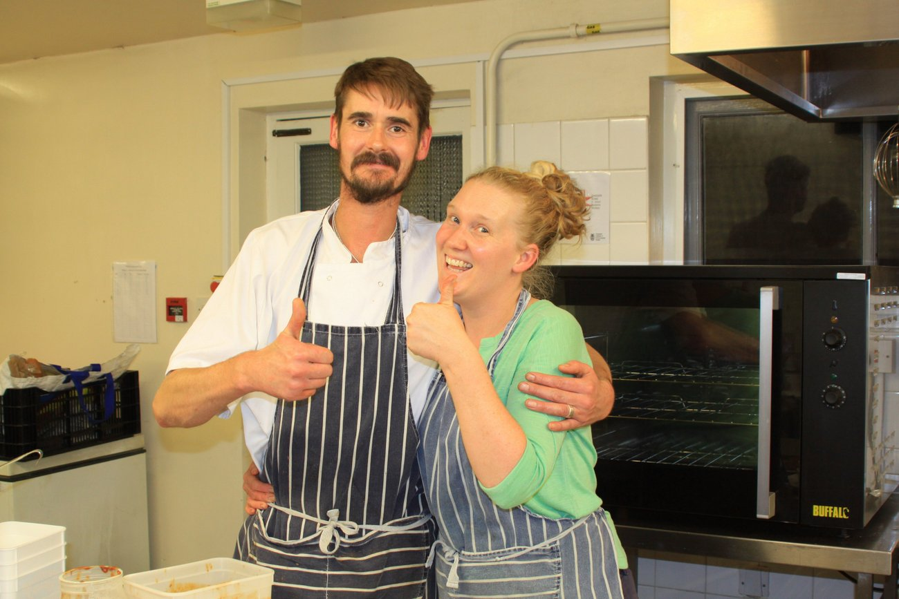
Thursday Lunches

Available from 12 - 2 pm
Our in-house chefs Matt & Louise will cook you a delicious meal from their specials menu, just pop in and take a look at the blackboard for details. Well worth a visit.
“No need to book”

Sunday Lunches

Due to a change in circumstances we are not able to offer, at present, our monthly roast as we had hoped, although we are still able to cater for group bookings. Please call Carol on 07929923433 to discuss your requirements.
Devizes Family Club
@Devizes Con Club
“Where Great Entertainment Lives”
Bringing families affordable live entertainment from some of the UK’s Best Tribute Artists
Doors open 7.30 pm. Under 16’s FREE

Visit www.devizesfamilyclub.co.uk for upcoming events, tickets and T&C’s.
All Tribute nights include a disco relevant to the genre. Videos of all artists & bands can be found on YOUTUBE.

Saturday 29th September 2018
Uk’s number 1 Tribute to Cher/Divas Tribute @ 8 pm Tickets £5

Saturday 20th April 2019
Katy Perry/Taylor Swift Tribute by Katie Ellis @ 8 pm Tickets £5

Sunday 28th April 2019
The Don Williams Tribute by Mitchell C Scott @ 8 pm Tickets £5

Friday 3rd May 2019
Hariana - A Tribute to Ariana Grande/Divas Tribute by Hannah Thomas @ 8 pm Tickets £5

Saturday 1st June 2019
Meet Loaf by Terry Nash @ 8 pm - 11.30 pm Tickets £5

Saturday 8th June 2019
The Keith Urban Tribute @ 8 pm Tickets £5

Saturday 6th July 2019
Pink by Zoe Alexander @ 8 pm - 11.30 pm Tickets £5

Saturday 13th July 2019
Rat Pack/Swing Tribute by Partners in Croon @ 8 pm - 11.30 pm Tickets £5

Saturday 20th July 2019
Little Chix (A Tribute to Little Mix) @ 8 pm Tickets £12

Saturday 28th September 2019
Carpenter’s Tribute/60’s & 70’s Tribute by Katy Ellis @ 8 pm Tickets £5

Saturday 19th October 2019
Rocky Horror Tribute by Mocky Horror @ 8 pm Tickets £10

Saturday 16th November 2019
Elvis 56’ and the If I Can Dream Band @ 8 pm Tickets £10
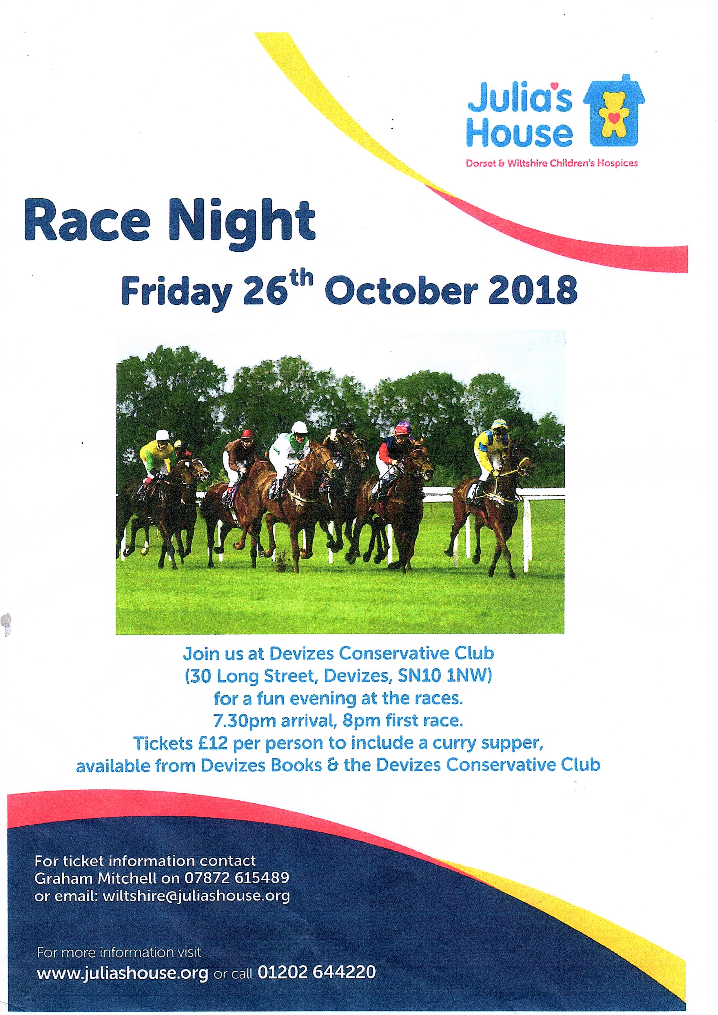
Julia’s House Race Night - Friday 26th October

The Club has kindly donated £100 to sponsor a race on the evening. There are eight horses in each race and in our race the horses and their owners are as follows:-

Horse Owner

Jerrimimer John Chowney
Roy's Dream Roy Surman
Lucky George Angela Smith-Avery
Stacey's Folly Con Club Bar Staff
Last Chance Ken and Chums
Griffin's Delight Chris Jones
Stacey's Spurs Nigel Brimble
Wyatt's Winner Pete Wyatt

Please come along and support this event. Tickets are now available at the bar this is sure to be a very enjoyable evening with your proceeds going to a great local charity that makes such a difference to people’s lives. Remember to choose your meal when buying tickets.

Long Street Blues Club

www.longstreetbluesclub.co.uk/gigs

All tickets available from the club bar

Season tickets available: All six gigs £70
Pick ‘n’ Mix five gigs £60

Saturday 8th September - Hamilton Loomis - Doors 7.45 pm, Main band 9.15 pm
Advance tickets: £16/£18 on the door.

Saturday 6th October - Del Bromham's Blue Devils and Ken Pustelnik's Groundhogs
Doors open 7.45 pm, Show starts 8.15 pm
Advance tickets: £16/£18 on the door

Saturday 20th October - Ryan McGarvey - Doors 7.45 pm, Main band 9.15pm
Advance tickets: £15/£17 on the door

Saturday 3rd November - The Malone Sibun Band - Doors 7.45 pm, Main band 9.15pm
Advance tickets: £15/£17 on the door

Saturday 17th November - Lightnin' Willie with All Star US Band - Doors 7.45 pm,
Main band 9.15pm
Advance tickets: £15/£17 on the door

Saturday 22nd December - We remember Joe Cocker - Doors 7.45 pm, Main band 9.15pm
Advance tickets: £16/£18 on the door
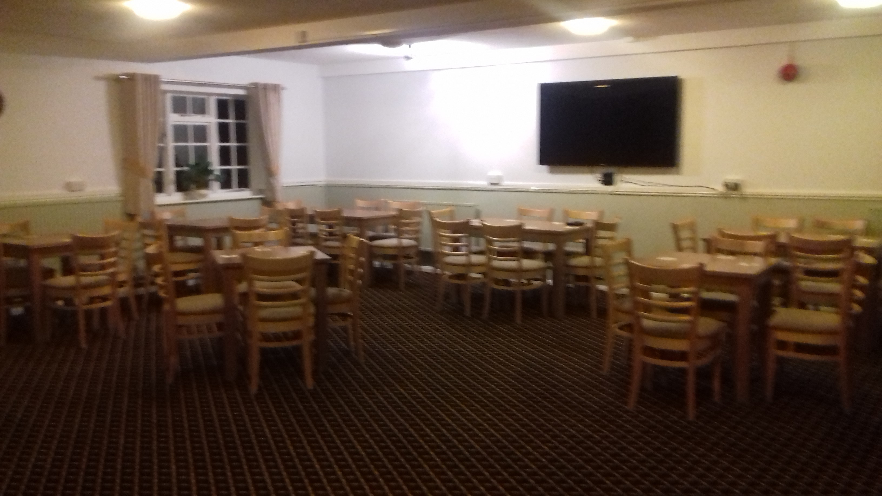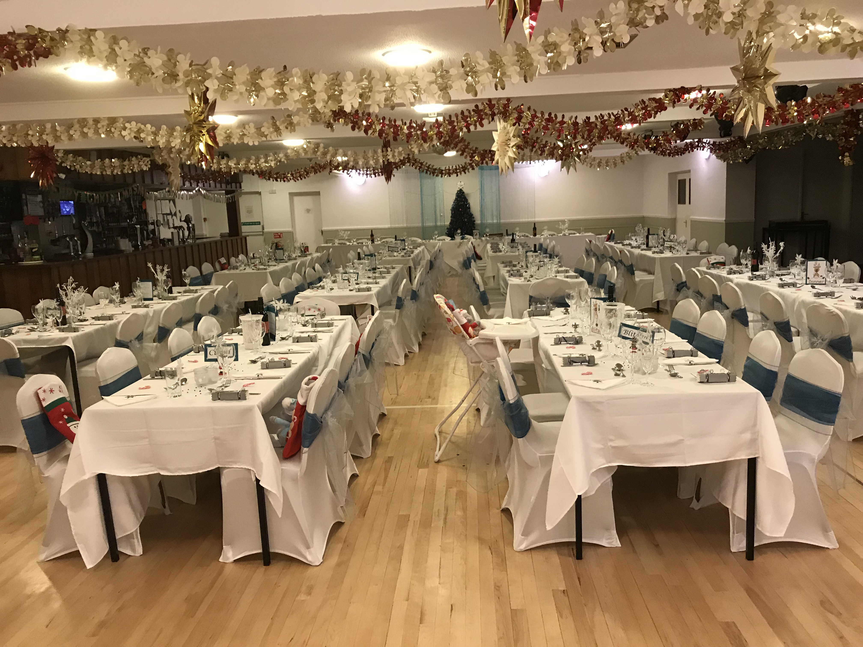 Main Function Room Recently refurbished meeting room complete with 65” TV Seats approximately 130 guests Seats approximately 50 guests

DO YOU HAVE A SPECIAL EVENT COMING UP THIS YEAR?

WE CAN ACCOMMODATE YOU

Weddings, Christenings, Wakes, Retirements, Presentation Evenings, Birthdays, Anniversaries, Children’s Parties, Fundraisers, Business Meetings, Clubs, Classes, Any Event Considered
Very Competitive Rates Friendly Helpful Staff
- Capacity 180/200
Call Carol on 01380 722005/07929923433 or
email devizesconservativeclub@hotmail.com
- Licensed Bar
- Flexible Catering
- Free Car Parking
BOOK EARLY TO AVOID DISAPPOINTMENT
I
- Tailored Packages to suit Your Individual Needs

Smiles Corner Episode 8

As the coffin was being lowered into the ground at a Traffic Warden’s funeral, a voice from inside screamed,
“I’m not dead, I’m not dead, let me out.”
The Vicar smiles, leans forward sucking air through his teeth and mutters, “Too late pal, I’ve already done the paperwork.”

Arriving home late a husband finds a note stuck on the fridge which reads, “This is not working, I have packed my bags and gone home to mother!”
Well, on opening the door, the light comes on and the beers are cold, so what’s the problem!

If lawyers are disbarred and clergymen defrocked, doesn't it follow that electricians can be delighted, musicians denoted, cowboys deranged, models deposed, tree surgeons debarked and dry cleaners depressed?
I had a rose named after me and I was very flattered. But I was not pleased to read the description in the catalogue: “No good in a bed, but fine against a wall.'"
(Eleanor Roosevelt)
People may forget what you do or say, but not how you make them feel.

Life is not measured by the number of breaths, but what takes our breath away.

Great minds discuss ideas,
Average minds discuss events,
Small minds discuss people.
(Eleanor Roosevelt)

Thought for the day

A holy man was having a conversation with the Lord one day and said, 'Lord, I would like to know what Heaven and Hell are like.
The Lord led the holy man to two doors. He opened one of the doors and the holy man looked in. In the middle of the room was a large round table. In the middle of the table was a large pot of stew, which smelled delicious and made the holy man's mouth water.
The people sitting around the table were thin and sickly. They appeared to be famished. They were holding spoons with very long handles that were strapped to their arms and each found it possible to reach into the pot of stew and take a spoonful. But because the handle was longer than their arms, they could not get the spoons back into their mouths. The holy man shuddered at the sight of their misery and suffering.
The Lord said, 'You have seen Hell.'
They went to the next room and opened the door. It was exactly the same as the first one.
There was the large round table with the large pot of stew which made the holy man's mouth water. The people were equipped with the same long-handled spoons, but here the people were well nourished and plump, laughing and talking.
The holy man said, 'I don't understand.'
'It is simple,' said the Lord. 'It requires but one skill. You see they have learned to feed each other, while the greedy think only of themselves.'
If you have a joke or a thought you would like to share with the members, and it can be anonymously, please email it to devizesconservativeclub@hotmail.com by the end of the month.

